RD Captions provided by Ying 20181011

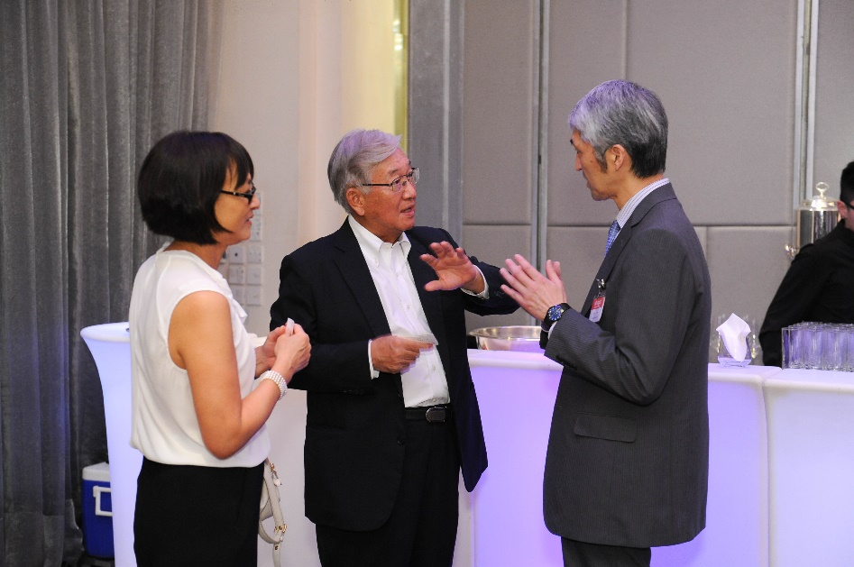

DSC 5699 –

RD with Dr Lo Ying-Ru and Dr Tatsuya Kanto, National Center for Global Health and Medicine from Tokyo, Japan at the 2016 First National Hepatitis Focal Points from selected high-burden countries in Asia in Hong Kong

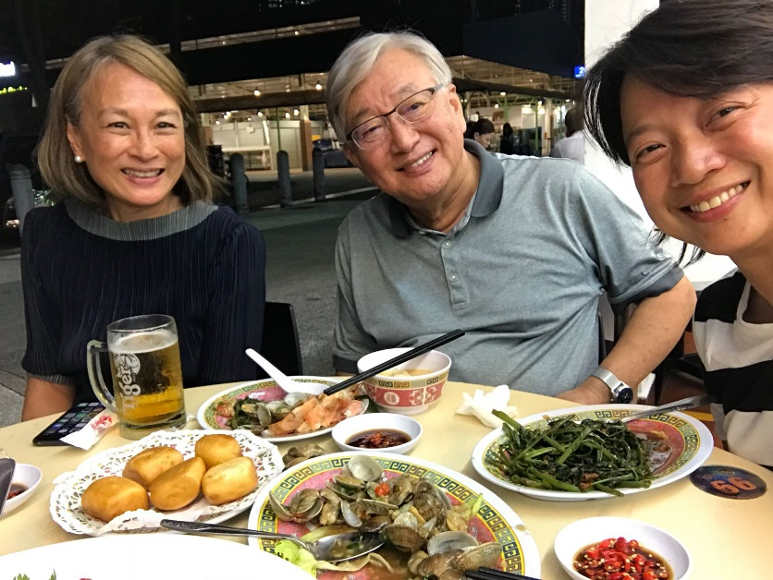

RD with Lo Ying-Ru and Dr Yeo Wen Qing, Former Deputy Director (International Cooperation), Ministry of Health Singapore having seafood dinner in Singapore in September 2018

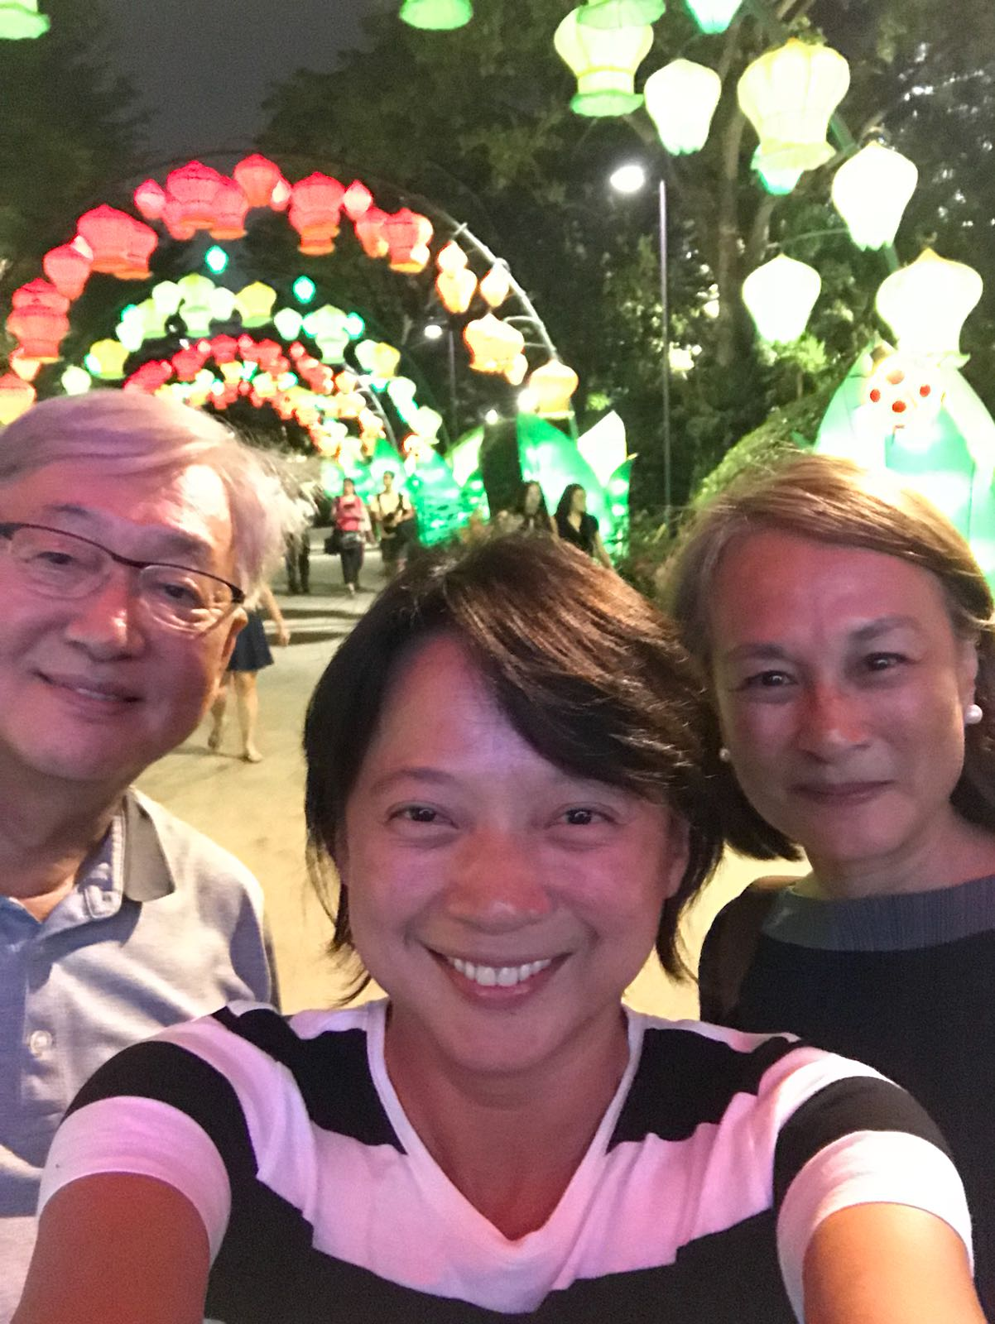

RD with Lo Ying-Ru and Dr Yeo Wen Qing, Former Deputy Director (International Cooperation), Ministry of Health Singapore sightseeing in Singapore in September 2018

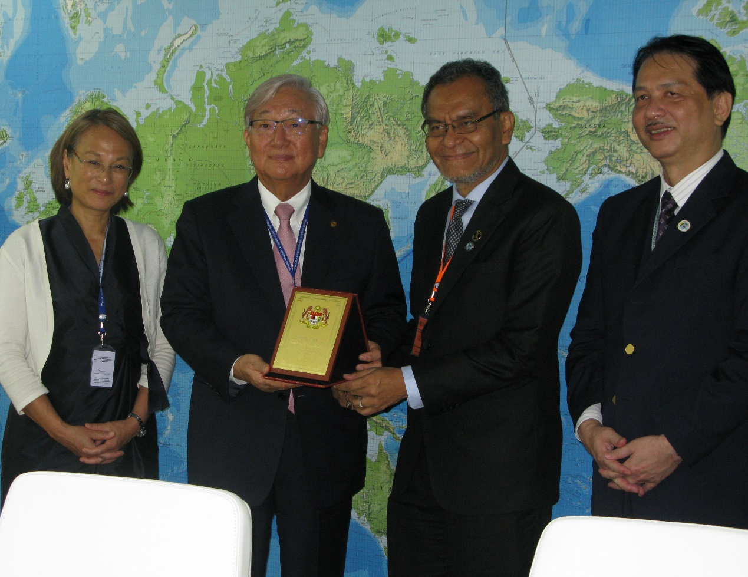

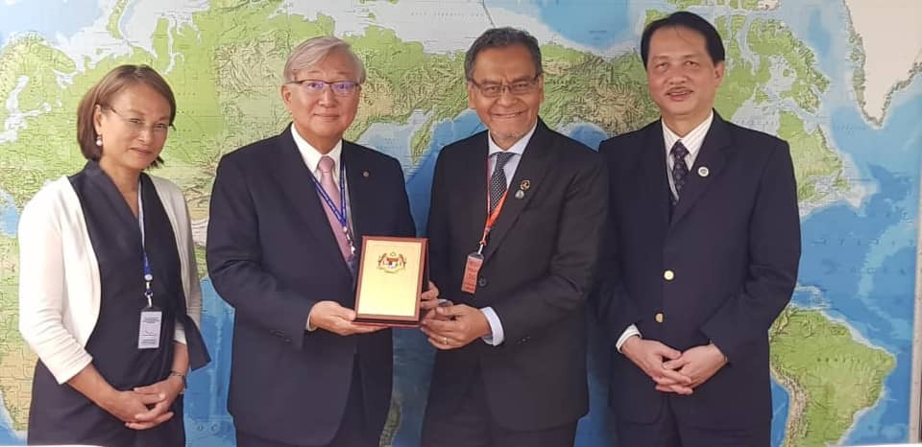

1. RD with token of appreciation during RCM 69 with the Honourable Dr Dzulkefly Ahmad, Minister of Health, Dr Dr Noor Hisham Abdullah, Director General of Health, Ministry of Health in RD’s Office.

, 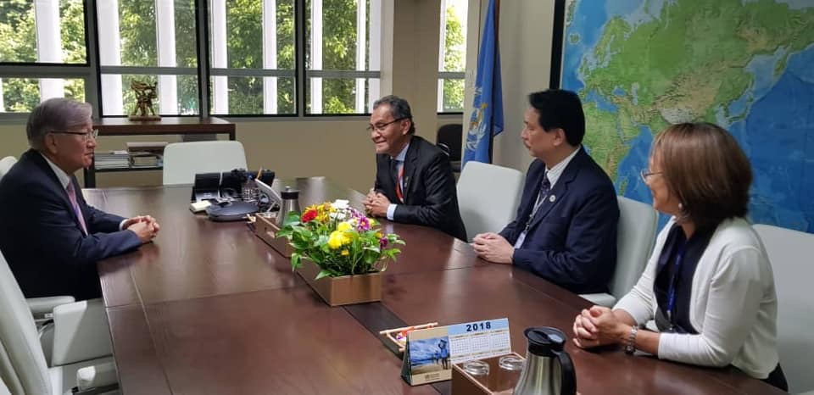

RD with discussing on health financing with the Honourable Dr Dzulkefly Ahmad, Minister of Health, Dr Dr Noor Hisham Abdullah, Director General of Health, Ministry of Health in RD’s Office

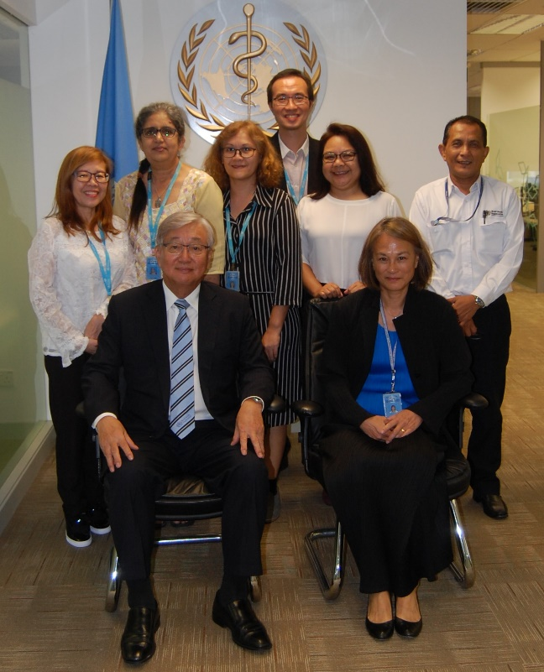

RD visiting the new WHO Country Office in Cyberjaya, 5 September 2018

Dr Lo Ying-Ru, Mustapha Hashim, Ms Sophie Nicholas, Dr Paul Soo, Ms Sheila Fernandez,

Ms Narwant (Rani) Mrs Ho Suet Yin.